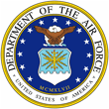
 | 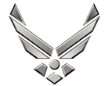

U N I T E D S T A T E S A I R F O R C E

LIEUTENANT COLONEL MICHAEL S. DEAL

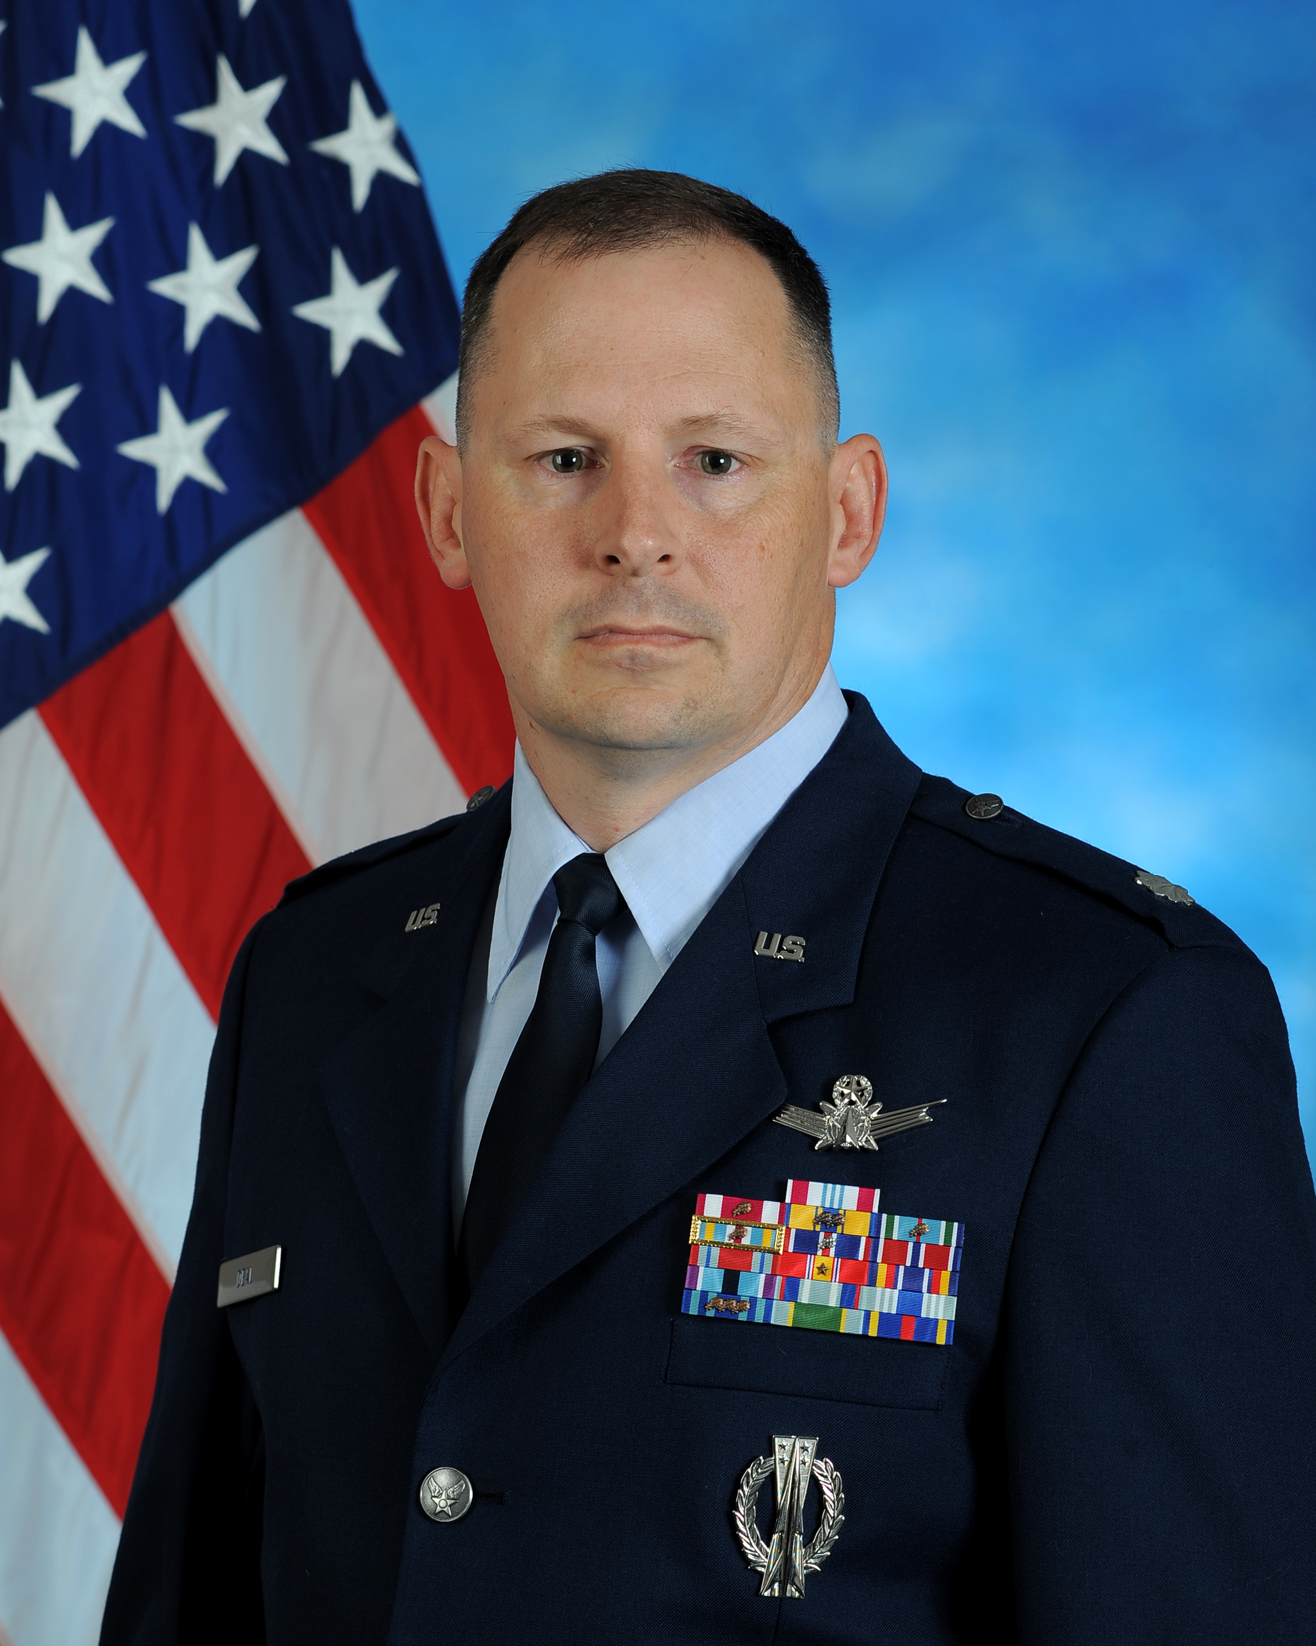
Lt Col Michael S. Deal is the Commander, AFROTC Detachment 835, University of North Texas, Denton, TX. Lt Col Deal leads the Aerospace Studies department for the College of Arts and Sciences.
Lt Col Deal entered the Air Force in March 1994 after earning a bachelor’s degree from the University of Texas-Austin. He received his commission through Officer Training School.
His career includes operational assignments in the space and missile career field. Lt Col Deal has operated the Minuteman III Intercontinental Ballistic Missile, the Global Positioning System, and the Hawaii Tracking Station.
Lt Col Deal has completed an Air Education and Training Command tour as an instructor, a staff tour at 14th Air Force, joint duty at United States Strategic Command, and has command experience at Det 4, 22 SOPS, Oahu, HI. Prior to his current assignment, Lt Col Deal worked in a joint assignment at United States Strategic Command as Chief, Non-Kinetic Strike and as Secretary of the Joint Staff.

EDUCATION
1993 Bachelor of Arts, Biology, University of Texas-Austin, Austin, TX
1994 Undergraduate Missile Training, Vandenberg AFB, CA (Distinguished Graduate)
1999 Global Positioning System Initial Qualification Training, Vandenberg AFB, CA
2000 Squadron Officer School, Maxwell AFB, AL
2002 Master of Science, Management, Troy State University, Troy, AL
2004 Air Command and Staff College (correspondence), Maxwell AFB, AL
2009 Joint Professional Military Education Phase II, Norfolk NAS, VA
2012 Air War College (correspondence), Maxwell AFB, AL

ASSIGNMENTS
1. Jul 94-Nov 94, Student, Missile IQT, 392d TRS, Vandenberg AFB, CA
2. Nov 94-Jan 99, Operations Support Flight Commander, Commander Instructor, Missile Combat Crew Commander, Deputy Evaluator, Deputy Instructor, Deputy Missile Combat Crew Commander, 10th Missile Squadron and 341st Operations Group, Malmstrom AFB, MT
3. Jan 99-Feb 02, Operations Flight Commander, Crew Commander, Satellite Vehicle Officer, 2d Space Operations Squadron, Schriever AFB, CO
4. Feb 02-Jan 04, Assistant Operations Officer, Flight Commander, Satellite Operations Lead Instructor, 533d and 534th Training Squadron, Vandenberg AFB, CA
5. Jan 04-Jun 05, Chief, Satellite Operations Branch, 14th Air Force/A33, Vandenberg AFB, CA
6. Jun 05-Jun 08, Commander, Detachment 4, 22 Space Operations Squadron, Oahu, HI
7. Jun 08-Jun 10, Chief, Non-Kinetic Strike, United States Strategic Command/J32, Offutt AFB, NE
8. Jun 10-Jul 11, Secretary of the Joint Staff, United States Strategic Command/J010, Offutt AFB, NE
9. Jul 11-Present, Commander, AFROTC Det 835, University of North Texas, Denton, TX

SUMMARY OF JOINT ASSIGNMENTS
1. Jun 08-Jun 10, Chief, Non-Kinetic Strike, United States Strategic Command/J32, Offutt AFB, NE
2. Jun 10-Jul 11, Secretary of the Joint Staff, United States Strategic Command/J010, Offutt AFB, NE

MAJOR AWARDS AND DECORATIONS
Defense Meritorious Service Medal
Meritorious Service Medal with one oak leaf cluster
Air Force Commendation Medal with two oak leaf clusters
Joint Service Achievement Medal with one oak leaf cluster
Joint Meritorious Unit Award with one oak leaf cluster
Air Force Combat Readiness Medal
National Defense Service Medal with bronze star
Global War on Terrorism Service Medal
Humanitarian Service Medal
Air and Space Campaign Medal

EFFECTIVE DATES OF PROMOTION
Second Lieutenant: Jun 22, 1994
First Lieutenant: Jun 22, 1996
Captain: Jun 22, 1998
Major: Dec 1, 2004
Lt Col: Nov 1, 2009

(Current as of Jul 12)

